**IGME: 771: WEEK 6-LAB**

1. **Research question**

My area of interest for this task was Chicago. I focused on Vehicle boundaries data obtained from acs.

Questions: 1. How many people living in Illinois, Chicago have 4 or more vehicle in one household.

2. Is there any household that has less than 4 vehicle.

1. **Datasets used:**

**For task 1:**

The datasets that I have used are: ACS vehicle availability boundaries.

**For task 2**

The dataset that I used was Rails.

1. **Screenshot of python expression.**

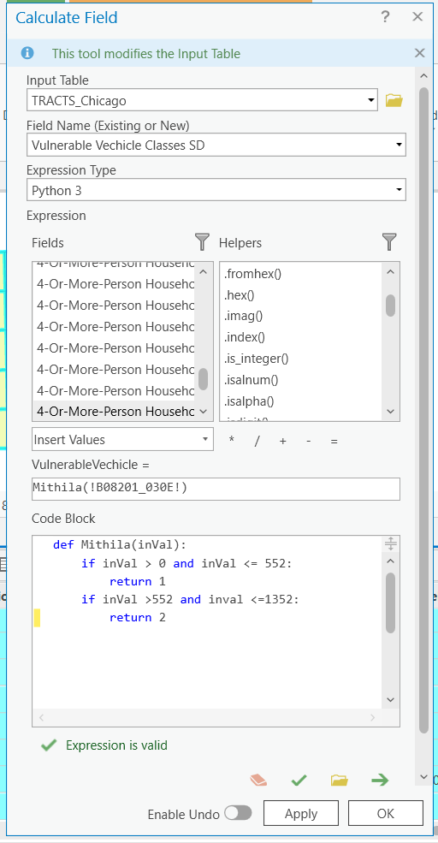.

1. **Screenshot of finished model builder.**

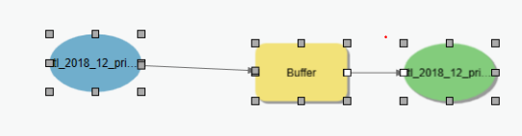

1. **Screenshot of map Task 3**

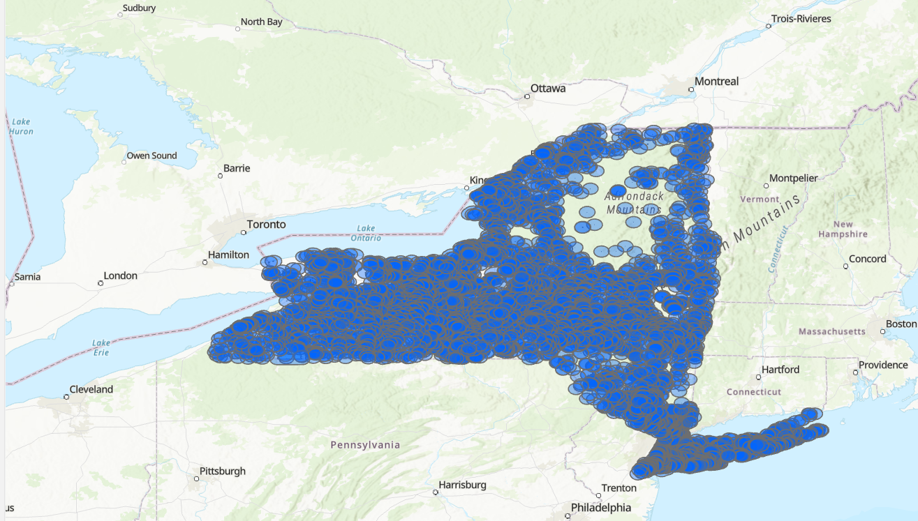

1. **Challenges and problems faced**

I did not face much issues during this assignment. I had a lot of fun while working with python. Python is my favourite language so it was interesting to see how it can be used with GIS. Also, I tried different model builder analysis tools to see how can we manipulate the dataset. s